
FINAL PROFESSIONAL MBBS (05)

KHYBER MEDICAL UNIVERSITY
 | PESHAWAR |  | Roll No__________
EXAMINATION ADMISSION FORM |  |  | 
 | FINAL PROFESSIONAL MBBS
Annual/ Supplementary 20______ |  |  | Paste photo
 |  |  | graph attested on face side
First Professional MBBS R.No._________ A/S______Session_________Marks___________________

Second Professional MBBS R.No._________ A/S______Session_________Marks______
Third Professional MBBS R.No. _______ A/S _______ Session_______ Marks________

Fourth Professional MBBS R.No.______________ A/S _______ Session_______ Marks________
University Registration No.
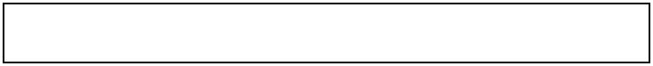

College Name:

- Name (IN BLOCK LETTERS) _____________________________________Gender______________

- Father’s Name (IN BLOCK LETTERS)___________________________________________________
3. CNIC No. | -

- Permanent address_________________________________________________________________

________________________________________________________ Phone No___________________

- Passed 4th Professional MBBS examination Annual/Supply under Roll No. ___________
Session_____________

- Appeared last time in Final Professional Examination under Roll No_____________________

Session________ (Annual/Supplementary) (Attach DMC).

- Subjects in which to be examined:
- Medicine
- Surgery
- Obstetrics & Gynaecology
- Paediatrics
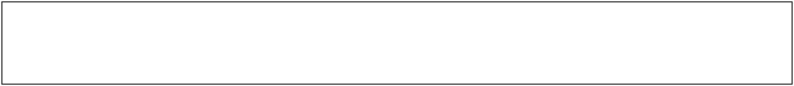

DECLARATION

I hereby solemnly declare that the particulars given above are correct. In case of any wrong information or concealment of facts I shall be responsible for the consequences. Further, I undertake to abide by the Rules and Regulations of Examination prescribed by the Khyber Medical University, Peshawar.

Dated_______________ |  | Signature of Candidate_________________
 |  | FOR OFFICE USE ONLY
Entries and result checked | He/She is Eligible/Ineligible |  |  | Allowed/Disallowed
and found correct.
Dealing Assistant/Supdt: |  | ACE |  | DCE
Remarks (if any)

CERTIFICATE

- I certify that the candidate has fulfilled the conditions laid down in the rules, that he/she is of good moral character; that he/she has signed this application: and his/her particulars over-leaf are correct.

- I certify that he/she completed the course of lectures, practical, demonstrations, clinical work etc.as prescribed in the regulations.

- I certify that he/she has passed the 4th Professional ….……... (Annual/Supply) Examination and is eligible to appear in Final Professional MBBS Examination.

- He/She has remitted Rs………………. (Rupees in words) ……………………………........………

………………………………………………………………………………….…………………………..

Vide Bank Draft No………………………..….Dated……………………..……..as Examination Admission Fee (attached).

Note: - All documents including Bank Draft to be attached here.
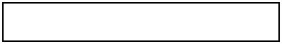

Principal

Signature __________________________________

Name of College ____________________________

Office Seal _________________________________

===============================================================================

INSTRUCTIONS : (TO BE READ CAREFULLY)

- Examination Admission Form duly completed in all respects should reach the controller of Examinations, Khyber Medical University Peshawar on or before the last date notified for the purpose failing which late fee will be charged.

- Fee once deposited is neither refundable nor adjustable if the candidate is otherwise eligible.

- Two different Examinations are not allowed in one session of examination.

- Incomplete forms will not be entertained.

- All candidates are required to attach three copies of passport size photographs and one copy of National Identity Card /Domicile Certificate duly attested by the principle concerned.

- Incomplete /unsigned forms will not be entertained and will be returned at the cost/risk of the candidate.

- Admission fee remitted through money order/cheque will not be accepted.

- No student is eligible for a university examination without having attended 75% of the lectures, demonstrations, tutorials, and practical or clinical work both inpatient and outpatient.

- Whatever may be the system of marking, for all examinations throughout the medical course the percentage of pass marks in each subject will not be less than 50% i.e., 50% in theory and 50% in practical

- No grace marks are allowed in any examination.

Student Signature _________________


KHYBER MEDICAL UNIVERSITY
 | PESHAWAR |  | Roll No_____________
Annual/Supplementary Examination 20_____
 | SUPERINTENDENT SLIP


(TO BE FILLED IN BY THE STUDENT)

[To be retained by Suptd. & returned to the

Exam. Section after termination of exam]
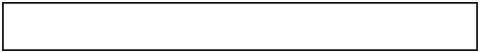

University Registration No.

Paste photo

graph attested

on back side

N.I.C.No. |  |  |  |  |  | - |  |  |  |  |  |  |  | -

Admit Mr./Mrs./Miss

Son/Daughter of

Of the ______________________________________________________ College for MBBS Final Professional Examination on the dates as given in the date sheet to the Centre for Examination at ________________________ ____________________________________________________________________________________________

Subjects In which to be examined

1._________________ 2._________________ 3.________________ 4.___________________

Deputy Controller of Examinations
Khyber Medical University
Peshawar.

___________________
Signature of Candidate
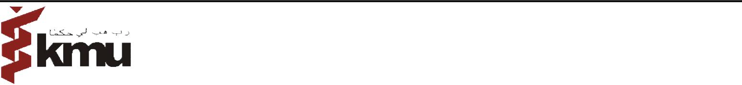

KHYBER MEDICAL UNIVERSITY

 | PESHAWAR |  | Roll No _____________
Annual/Supplementary Examination 20_____
 | STUDENT SLIP

(TO BE FILLED IN BY THE STUDENTIN HIS/HER HAND WRITING)

[To be retained by the Candidate]
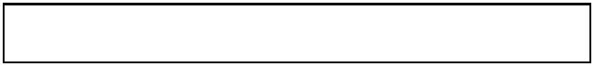

University Registration No.

N.I.C.No. |  |  |  |  |  | - |  |  |  |  |  |  |  | -

Admit Mr./Mrs./Miss

Son/Daughter of

Paste photo graph attested on back side

Of the ______________________________________________________ College for MBBS Final Professional Examination on the dates as given in the date sheet to the Centre for Examination at ________________________ ____________________________________________________________________________________________

Subjects In which to be examined

1._________________ 2._________________ 3.________________ 4.___________________

Deputy Controller of Examinations
Khyber Medical University
Peshawar.

___________________
Signature of Candidate

